How to Request Permission to Participate in Moonlighting Activities - Instructions for Housestaff
All trainees who wish to participate in moonlighting activities must be in good standing and request written permission via the following process:

- Download the “UCLA Moonlighting Request & Approval” document (available in the Moonlighting Information folder in the Resources/Documents section of your MedHub home page or from the GME website) and save as a PDF with another name before filling in completely.

NOTE: Internal moonlighting requests require input and electronic signature of the faculty member requesting your participation (must not be your program director) on this form. After completing the fields for supervisor name, title, contact information and your own electronic signature, save and email or print the form making it available for the faculty member named as supervisor to complete the required “reason for staffing request” and “Level of post-….” fields.

- All moonlighting requests include uploading the form completed in Step 1 to a short dynamic form in MedHub:
  - Log in to in MedHub and select Moonlighting Request Forms from the Request Forms section on the left-hand side of your home page.
  - Select Submit New Moonlighting Request and complete the dynamic form, including the inclusive dates of your moonlighting activity (dates must be within the current academic year only). 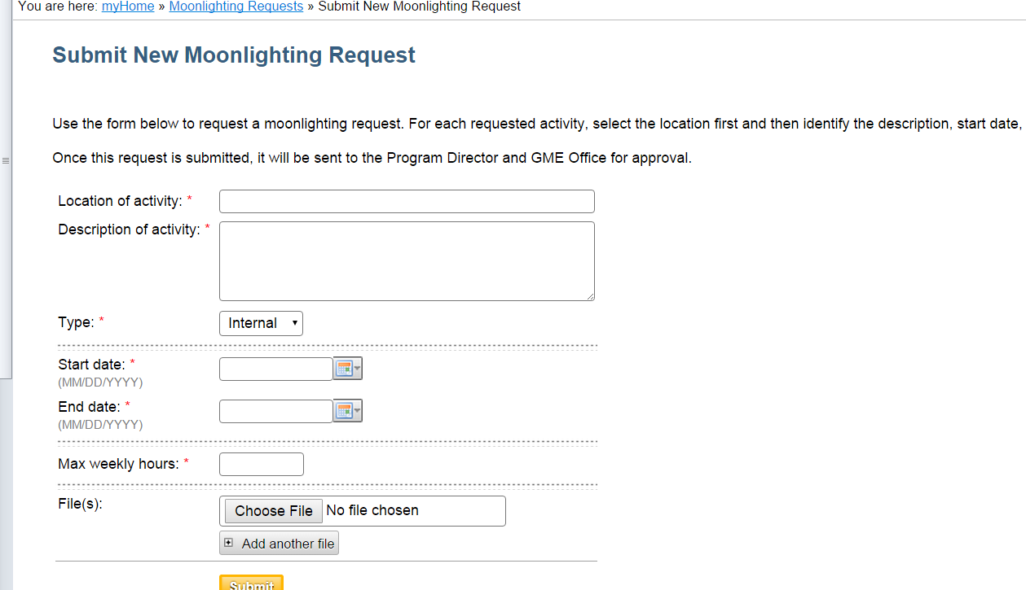
  - Select Choose File to upload the complete and saved version of the “UCLA Moonlighting Request & Approval” document.
  - Select Submit
MedHub will route your request to your Program Director for approval, then to the GME Director or DIO for approval. You will receive notification upon final approval of your request.
NOTE: Hours worked in moonlighting activities must be logged as duty hours on your Resident Duty Hours timesheet. Do this by selecting “Moonlighting” in the grey hours drop down box:
